**PancakeSwap BNB Price prediction**

Officially produced by PancakeSwap, after multiple backtests, it maintains a stable accuracy rate of around 90%.

Function: Predicts whether the BNB price will rise or fall in 5 minutes, based on BNB trends.Automated reward claiming with a fully automated bot.

**Existing projects**

| **Project name** | **Description** | **Solidity version(s)** |
| --- | --- | --- |
| [BSC Library](https://github.com/pancakeswap/pancake-smart-contracts/blob/master/projects/bsc-library) | Legacy implementation of BEP20/IBEP20/SafeBEP20. Not to be used for new contracts. | 0.6.12 |
| [Cake Vault](https://github.com/pancakeswap/pancake-smart-contracts/blob/master/projects/cake-vault) | CAKE vault ("AutoPool") contract that allows auto-compounding for CAKE tokens. | 0.6.12 |
| [Exchange Protocol](https://github.com/pancakeswap/pancake-smart-contracts/blob/master/projects/exchange-protocol) | Based on Uniswap V2, it combines peripheral and core trading and liquidity protocols. It also adds new features like zaps. | 0.5.16 / 0.6.6 / 0.8.4 |
| [Farms and Pools](https://github.com/pancakeswap/pancake-smart-contracts/blob/master/projects/farms-pools) | Based on SushiSwap's MasterChef, it also includes stand-alone pools and pool deployer. | 0.6.12 |
| [Farm Auctions](https://github.com/pancakeswap/pancake-smart-contracts/blob/master/projects/farm-auctions) | System for community-based auctions for future CAKE farms. | 0.8.4 |
| [IFO](https://github.com/pancakeswap/pancake-smart-contracts/blob/master/projects/ifo) | Initial Farm Offerings. | 0.6.12 |
| [Lottery](https://github.com/pancakeswap/pancake-smart-contracts/blob/master/projects/lottery) | V2 Lottery system for CAKE built using Chainlink's VRF. | 0.8.4 |
| [NFT Markets](https://github.com/pancakeswap/pancake-smart-contracts/blob/master/projects/nft-markets) | NFT marketplace for ERC721 tokens. | 0.8.4 |
| [Pancake Squad](https://github.com/pancakeswap/pancake-smart-contracts/blob/master/projects/pancake-squad) | Pancake Squad NFT collection. | 0.8.4 |
| [Predictions](https://github.com/pancakeswap/pancake-smart-contracts/blob/master/projects/predictions) | Prediction protocol contract built using Chainlink's oracle. | 0.6.12 (v1) / 0.8.4 (v2) |
| [Profile, NFT, and Gamification](https://github.com/pancakeswap/pancake-smart-contracts/blob/master/projects/profile-nft-gamification) | Pancake Bunnies NFT, NFT factories, and Profile system. | 0.6.12 |
| [SmartChef Factory](https://github.com/pancakeswap/pancake-smart-contracts/blob/master/projects/smartchef) | SmartChef (a.k.a. Syrup Pools) Factory | 0.6.12 (v1) / 0.8.4 (v2) |

**Test record screenshots**

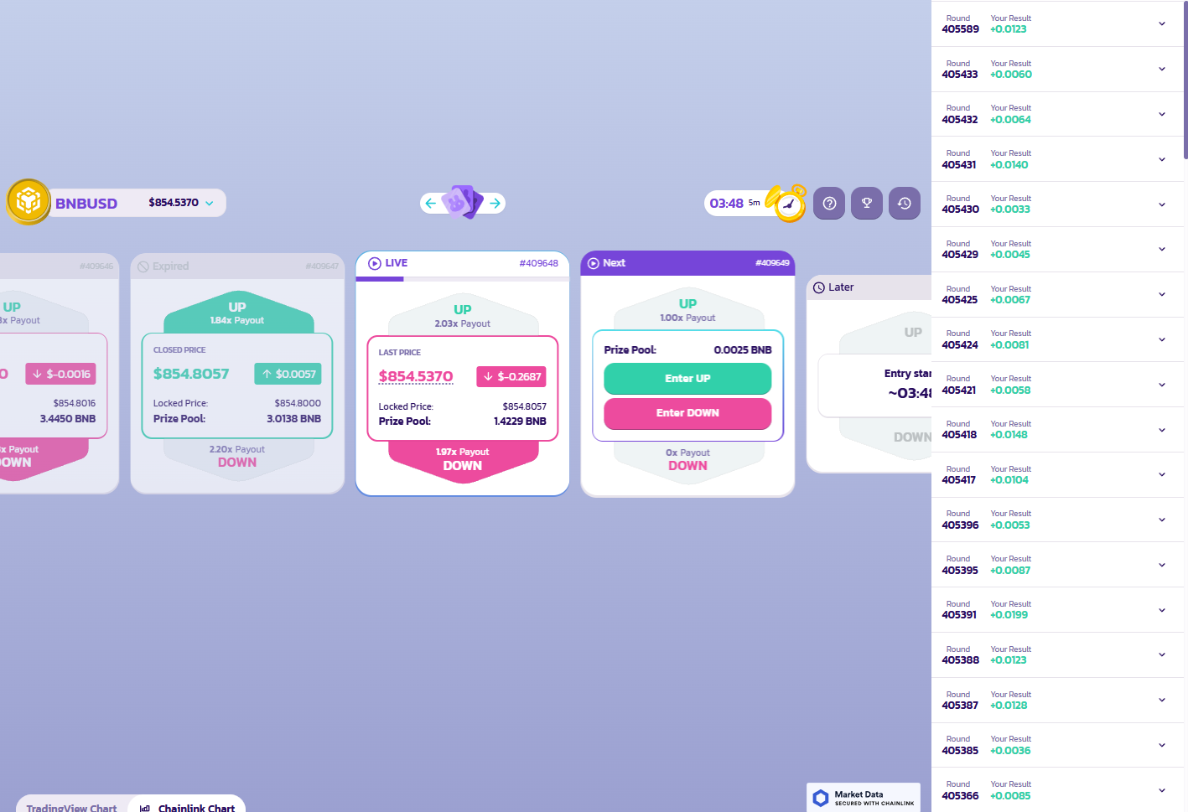

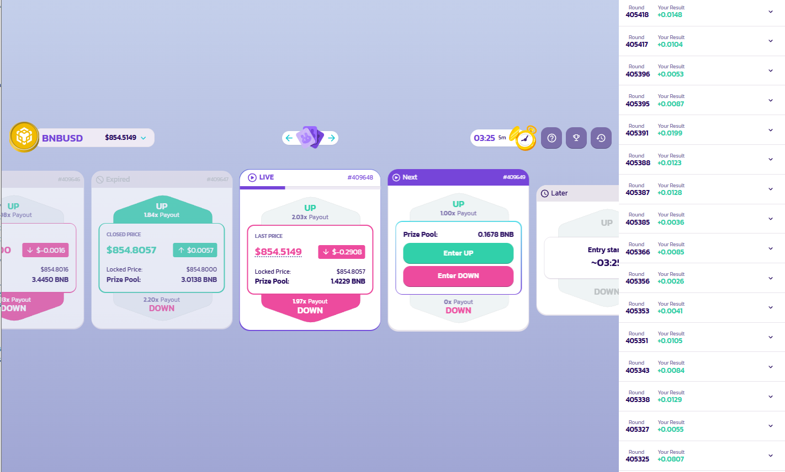

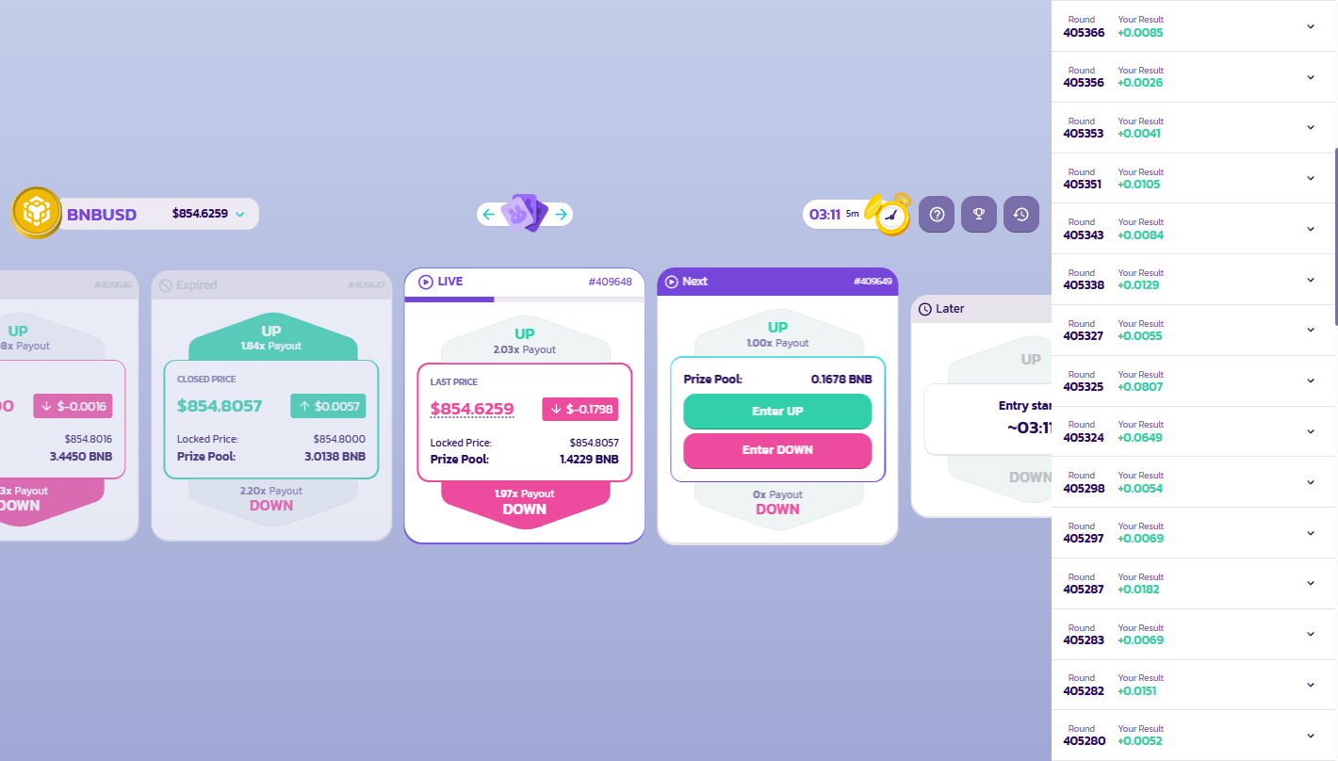

**How to use**

1. Select language
2. Enter the mnemonic
3. Choose a betting

Formula：A (Win rate 95%) 2. Formula B (Win rate 93%) 3. Formula C (Win rate 90%)

1. Enter the bet amount (0.01~1)
2. Run the program and start automatic betting

